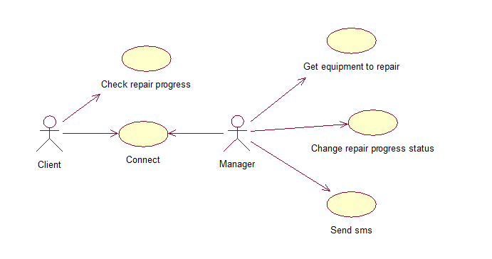

**Events flow for the precedent «Check repair progress»**

Short description:

Client uses check repair progress for gets information about his equipment, which is in repair.

Preconditions:

1. The client should have a hash code.
2. The equipment should be in repair.

Main way:

1. Client types a hash code into a form.
2. Check repair progress page was opened.

Alternative way:

1. Client types a hash code into a form.
2. Hash code was wrong.
3. Form was flushed.

Postconditions:

1. Repair progress graph was showed.

**Events flow for the precedent «Connect»**

Short description:

Client and manager use this event for communication with each other.

Preconditions:

1. The client should have a hash code.
2. The client should be authorized in the system.
3. The administrator should be authorized in the system.

Main way:

1. Client or manager fill in a feedback form.
2. Client or manager send a feedback form.
3. Feedback form was flushed.

Postconditions:

1. Message was saved in database.
2. Personal messages were updated.

**Events flow for the precedent «Get equipment to repair»**

Short description:

Get an equipment to repair allows watch repair status to user.

Preconditions:

1. The administrator should be authorized in the system.

Main way:

1. Manager gets an equipment to repair.
2. Manager filled in form about the client.
3. Manager filled in form about the equipment.
4. Information was saved.

Alternative way:

1. Manager gets an equipment to repair.
2. Manager filled in form about the client.
3. Manager filled in form about the equipment.
4. Information was incorrect.

Postconditions:

1. The hash code was generated.
2. The information from forms save in database.
3. The client got hash code vie sms.

**Events flow for the precedent «Send sms»**

Short description:

Manager uses sms for notify user.

Preconditions:

1. The manager should be authorized in the system.

Main way:

1. Manager fills in sms form.
2. Manager sends sms to a client.

Alternative way:

1. Manager fills in sms form.
2. End money in the organization account.

Postconditions:

1. Sms saves in database.
2. A client gets sms.

**Events flow for the precedent «Change repair progress status»**

Short description:

Manager changes repair progress status, for update information about client’s equipment information.

Preconditions:

1. The manager should be authorized in the system.

Main way:

1. Manager found the equipment.
2. Manager changes the equipment repair progress status.

Alternative way:

1. Manager did not find the equipment.

Postconditions:

1. Database information about the repair progress status was updated.
2. The repair progress graph was changed.